Newsroom Story Clustering and Wire Deduplication Platform

Project Report submitted for the partial fulfilment of grade for the course

Data Structures and Algorithms -3 (25CS2103E)
in

A.Y. 2026-2027

Submitted by
K. Keathana Vikashini (2520090236)
Lahari Namala (2520090226)
G. Karthikeya (2520090103)

Team Number: 8
Section: 13

Under the guidance of

Dr. Dyuti Banerjee

Asst. Professor,AI&DS
Hyderabad-500090, Telangana, India.

K L (Deemed to be) University
DEPARTMENT OF COMPUTER SCIENCE ENGINEERING / COMPUTER SCIENCE AND INFORMATION TECHNOLOGY/ARTIFICIAL INTELLIGENCE & DATA SCIENCE



DECLARATION

The Mini Project Report entitled “Newsroom Story Clustering and Wire Deduplication Platform” is a record of Bonafide work of K. Keathana Vikashini – 2520090236, Lahari Namala – 2520090226, G. Karthikeya – 2520090103 submitted in partial fulfillment for the award of B. Tech in Computer Science and Engineering/Computer Science and Information Technology/ Artificial Intelligence & Data Science to the K L University. The results embodied in this report have not been copied from any other departments/University/Institute.

K. Keathana Vikashini – 2520090236
Lahari Namala – 2520090226
G. Karthikeya – 2520090103

K L (Deemed to be) University
DEPARTMENT OF COMPUTER SCIENCE ENGINEERING / COMPUTER SCIENCE AND INFORMATION TECHNOLOGY
CERTIFICATE

This is to certify that the mini project based report entitled “Newsroom Story Clustering and Wire Deduplication Platform” is a bonafide work done and submitted by K. Keathana Vikashini – 2520090236, Lahari Namala – 2520090226, G. Karthikeya – 2520090103 in partial fulfillment of the requirements for the award of the degree of BACHELOR OF TECHNOLOGY in Department of Computer Science Engineering/ Computer Science and Information Technology/Artificial Intelligence & Data Science, K L (Deemed to be University), during the academic year 2026-2027.

Signature of the Supervisor

Signature of the HOD Signature of the External Examiner

ACKNOWLEDGEMENT

The success in this project would not have been possible but for the timely help and guidance rendered by many people. Our wish to express my sincere thanks to all those who has assisted us in one way or the other for the completion of my project.

Our greatest appreciation to our guide, Dr. Dyuti Banerjee, <<Designation>>, <<Department>>, which cannot be expressed in words, for her tremendous support, encouragement and guidance for this project.

We express our gratitude to Dr. P.Venkateshwar Rao (CSE)/Dr. Khaja Shareef (CSIT)/ Dr. Sreenath Itikela (AI&DS), Head of the Department for Computer Science Engineering/ Department for Computer Science and Information Technology/Department of Artificial Intelligence and Data Science for providing us with adequate facilities, ways and means by which we are able to complete this project-based Lab.

We thank all the members of teaching and non-teaching staff members, and also who have assisted me directly or indirectly for successful completion of this project. Finally, I sincerely thank my parents, friends and classmates for their kind help and cooperation during my work.

K. Keathana Vikashini – 2520090236
Lahari Namala – 2520090226
G. Karthikeya – 2520090103

TABLE OF CONTENTS

S.No. | Contents | Page no.
1. | Abstract | 6
2. | Introduction | 7
3. | Literature survey | 9
4. | Problem Statement and Objectives | 12
5. | Hardware and Software requirements | 13
6. | Implementation | 14
7. | Results & Discussion | 23
8. | Conclusion & Future Scope | 26
9. | References | 27

1. ABSTRACT
News agencies and digital newsrooms receive thousands of wire stories every day from services such as Reuters, AP and PTI and from many other publishers. A large share of these articles report the same event, and many are near-copies of the same wire text with only a few words changed. This clutters the feed for readers and forces editors to group and filter stories by hand.
This project presents a Newsroom Story Clustering and Wire Deduplication Platform that solves the problem using core Data Structures and Algorithms. Every article is cleaned, tokenized and stripped of stopwords, then converted into a set of 3-word shingles hashed with a rolling hash and a 128-value MinHash signature. Exact Jaccard similarity on shingles (≥ 0.60) flags duplicate copies, while MinHash similarity (≥ 0.12) decides which articles belong to the same story; a Union-Find structure with path compression merges them into story clusters. A max heap ranks the stories by priority, reach or date, and a Trie with a KMP fallback provides search-as-you-type. Three newsroom tools complete the system: a 0/1 knapsack dynamic program plans the front page, an Edmonds-Karp max-flow assigns stories to editors within capacity, and greedy set cover picks the fewest publishers that cover every story.
The platform is built with Python (Flask), SQLite and an HTML/CSS/JavaScript dashboard. On the sample dataset of 20 articles it produced 7 ranked stories, caught all 3 duplicate copies (83–87% overlap) and passed all 15 unit tests.
Keywords: Shingling, MinHash, Jaccard similarity, Union-Find, Max Heap, Trie, KMP, Knapsack DP, Max Flow, Greedy Set Cover.
Team Name: Team 8 (Section 13)
Team Logo (if any): —
Team Members:
- K. Keathana Vikashini, 2520090236
- Lahari Namala, 2520090226
- G. Karthikeya, 2520090103

2. INTRODUCTION
2.1 Background
In a modern newsroom, the same event is reported by many sources within minutes. Wire services publish the first version, and syndicated partners republish it with small edits such as an added dateline, a changed headline word or the phrase “on Tuesday”. A breaking story can therefore appear five or ten times in an incoming feed, mixed with genuinely different reports about the same event from other angles.
2.2 Motivation
Simple methods do not handle this well. Matching only headlines or URLs misses reworded copies, while comparing the full text of every article with every other article is slow and does not scale as the feed grows. Editors end up grouping stories manually, and readers see the same news again and again. What is needed is a compact, fast way to measure how similar two articles are and an efficient way to group many similar articles together.
2.3 Our Approach
Our platform answers the what, why and how of this problem with DSA techniques:
- Fingerprints: each article is turned into hashed 3-word shingles and a 128-number MinHash signature, so similarity can be measured without comparing full texts.
- Grouping: similar articles are merged into one story with a Union-Find (disjoint set) structure, and near-identical copies are marked as duplicates using Jaccard similarity.
- Presentation: stories are ranked with a max heap, searched with a Trie and KMP, and planned with DP, max flow and greedy set cover on a web dashboard.
Figure 2.1 shows a real example from our sample data: four articles about the EU AI regulation from Reuters, Financial Times, Politico Europe and Euronews are grouped into a single story, and the Euronews article is identified as a duplicate of the Reuters wire.
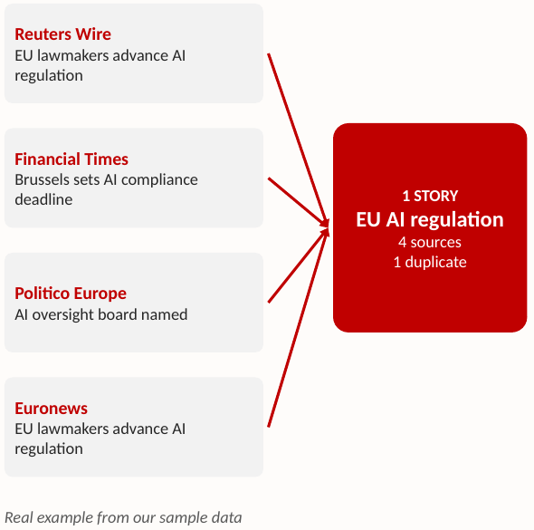
Figure 2.1: Four source articles grouped into one story with one duplicate
The rest of this report covers the literature survey (Chapter 3), the problem statement and objectives (Chapter 4), requirements (Chapter 5), the design and code of the implementation (Chapter 6), the results (Chapter 7), and the conclusion and future scope (Chapter 8).

3. LITERATURE SURVEY
3.1 A. Z. Broder (1997) – On the resemblance and containment of documents. Broder defined the resemblance of two documents as the Jaccard similarity of their sets of contiguous word sequences (shingles), and showed that min-wise independent hashing can estimate this resemblance from small sketches. The technique was developed for the AltaVista search engine to detect near-duplicate web pages. Our project uses exactly this idea: 3-word shingles, Jaccard for duplicate detection and MinHash signatures for similarity estimation.
3.2 M. S. Charikar (2002) – Similarity estimation techniques from rounding algorithms. Charikar introduced SimHash, a locality-sensitive hashing scheme in which short bit fingerprints agree in a fraction of bits that reflects the cosine similarity of the original vectors. The paper shows that compact fingerprints can replace expensive full-text comparison. It motivates our design choice of fixed-length fingerprints for every article.
3.3 M. Henzinger (2006) – Finding near-duplicate web pages: a large-scale evaluation of algorithms. Henzinger compared Broder’s shingling (MinHash) with Charikar’s SimHash on 1.6 billion web pages. Both methods found near-duplicates with good precision, with each performing better in different situations. The study supports our use of shingling plus hashing as a proven approach for near-duplicate detection at scale.
3.4 G. S. Manku, A. Jain and A. Das Sarma (2007) – Detecting near-duplicates for web crawling. This Google work applied 64-bit SimHash fingerprints to a repository of eight billion pages and presented fast techniques for finding all fingerprints that differ in only a few bit positions. It shows how fingerprinting can be made efficient in a production crawler, which is the same throughput problem a newsroom faces with a high-volume wire feed.
3.5 A. Das, M. Datar, A. Garg and S. Rajaram (2007) – Google News personalization. The authors built the recommendation system for Google News and used MinHash-based clustering of users’ click histories, combined with other methods, to serve millions of users. Although they cluster users rather than articles, the paper demonstrates that MinHash clustering is practical on a real news platform at very large scale.
3.6 R. E. Tarjan (1975) – Efficiency of a good but not linear set union algorithm. Tarjan proved that the disjoint-set (Union-Find) structure with path compression and union by rank runs in O(m·α(n)) time for m operations, where α is the extremely slow-growing inverse Ackermann function. This makes each union and find nearly constant time in practice. We use this structure to merge similar articles into story clusters efficiently.
3.7 J. Leskovec, A. Rajaraman and J. D. Ullman – Mining of Massive Datasets (Chapter 3). This textbook gives a complete treatment of finding similar items: shingling, Jaccard similarity, MinHash signatures and locality-sensitive hashing (LSH) with banding. It explains why the fraction of matching MinHash values is an unbiased estimate of Jaccard similarity. We followed this chapter for our MinHash implementation, and LSH banding is listed as our main future scalability step.
3.8 D. E. Knuth, J. H. Morris and V. R. Pratt (1977) – Fast pattern matching in strings. The KMP algorithm finds a pattern in a text in O(n + m) time by pre-computing a failure (prefix) table, so the text pointer never moves backwards. We use KMP as the fallback in our search module when no indexed word starts with the user’s query, allowing a match anywhere inside a headline.
3.9 J. Edmonds and R. M. Karp (1972) and V. Chvátal (1979) – Max flow and greedy set cover. Edmonds and Karp showed that choosing shortest augmenting paths with BFS makes the Ford-Fulkerson method run in O(VE²) time; we use it to assign stories to editors without exceeding capacity. Chvátal proved that the greedy heuristic for set cover is within a factor H(n) ≈ ln n of optimal; we use it to choose the fewest publishers that together cover all stories.
Table 3.1: Summary of the literature survey
Reference | Key idea | How we use it
Broder (1997) | Shingles + Jaccard; min-wise hashing | 3-word shingles, Jaccard duplicates, MinHash
Charikar (2002) | SimHash compact fingerprints | Fingerprints instead of full-text comparison
Henzinger (2006) | Shingling vs SimHash on billions of pages | Supports shingling + hashing
Manku et al. (2007) | Fingerprint near-duplicates at crawler scale | Throughput for high-volume feeds
Das et al. (2007) | MinHash clustering at Google News scale | MinHash is practical for news
Tarjan (1975) | Union-Find with path compression ≈ O(1) | Merging articles into stories
Leskovec et al. (MMDS) | MinHash, LSH banding | MinHash design; LSH as future work
Knuth–Morris–Pratt (1977) | Linear-time string matching | Search fallback
Edmonds–Karp; Chvátal | Max flow; greedy set cover | Editor desk; publisher coverage

4. PROBLEM STATEMENT AND OBJECTIVES
Problem Statement: Newsroom feeds are flooded with many reports of the same event and near-identical wire copies, and there is no fast, automatic way to group them into stories and remove the duplicates.
Problem Description: Editors group related articles by hand while readers see the same news repeatedly; exact headline matching misses reworded copies and comparing every pair of full texts is too slow, which also makes searching and ranking stories difficult.
Objectives:
Identify the Project’s Purpose: The project was initiated to reduce the manual effort of editors and the clutter seen by readers by applying efficient DSA techniques to wire-story processing. Its objectives are:
- Automatically group similar articles into story clusters (MinHash + Union-Find).
- Detect near-duplicate news copies (shingling + Jaccard similarity).
- Select a lead article for each story (highest-scored original article).
- Rank stories by priority, reach or date (max heap).
- Provide fast search and a web dashboard (Trie + KMP, Flask + HTML/CSS/JS).
- Support front-page planning, editor assignment and publisher coverage (knapsack DP, max flow, greedy set cover).

5. HARDWARE AND SOFTWARE REQUIREMENTS
Hardware Requirements:
- Processor: Intel Core i5 or higher
- RAM: 8 GB minimum (16 GB recommended for large datasets)
- Storage: 5 GB free disk space
- Internet: required only for live wire feeds
- Peripherals: display, keyboard and mouse
Software Requirements:
- Language: Python 3.10 or above
- Backend: Flask (REST API)
- Database: SQLite (newsroom.db)
- Frontend: HTML, CSS and JavaScript
- Data: JSON sample files (20 articles, 5 editors)
- Testing: Python unittest
- Tools / OS: VS Code, Git; Windows, Linux or macOS
Note: all text processing and algorithms are written from scratch in plain Python, so no external NLP or numerical library (such as NLTK or NumPy) is required.

6. IMPLEMENTATION
6.1 Flow of the System
Figure 6.1 shows how one batch of articles is processed. The text of each article is cleaned, tokenized and stripped of stopwords; fingerprints are built with hashing and MinHash; similarity is checked; Union-Find forms the clusters; duplicates are marked; stories are ranked; and the result is shown on the dashboard.
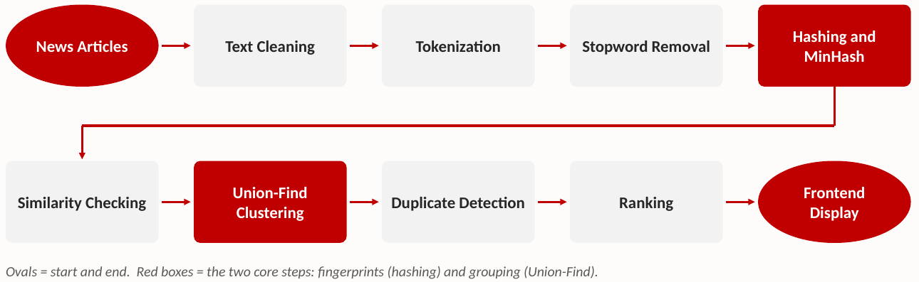
Figure 6.1: Flow chart of the processing pipeline
Decision rules: MinHash similarity ≥ 0.12 → same story (union); Jaccard overlap ≥ 0.60 → the later article is a duplicate copy.
6.2 System Architecture
The user works on the frontend dashboard. When something changes (for example, the similarity slider is moved), app.js calls the Flask REST API. Flask reads the articles from SQLite, runs them through the DSA modules in the core/ folder, and returns JSON; the browser then redraws the story cards.
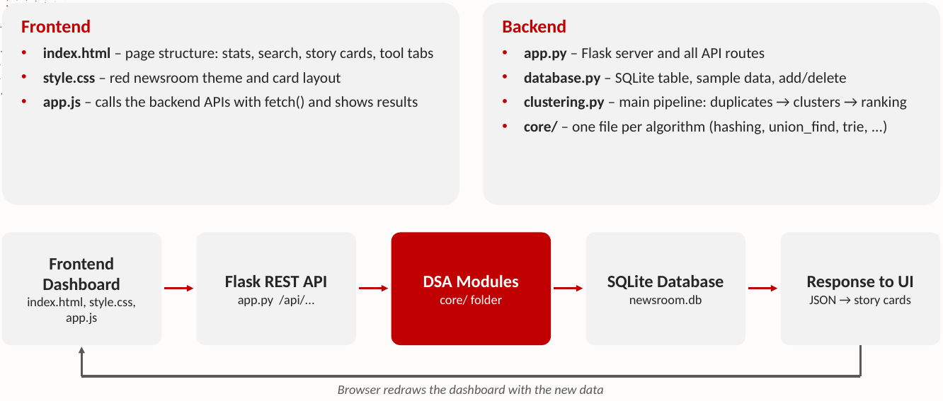
Figure 6.2: System architecture
Table 6.1: Project files and their roles
Layer | File | Responsibility
Frontend | index.html | Page structure: stats, search, story cards, tool tabs
Frontend | style.css | Red newsroom theme and card layout
Frontend | app.js | Calls backend APIs with fetch() and renders results
Backend | app.py | Flask server and all /api/... routes
Backend | database.py | SQLite table, sample data, add/delete articles
Backend | clustering.py | Main pipeline: duplicates → clusters → ranking
Backend | core/ | One file per algorithm (hashing, union_find, trie, planning …)

6.3 DSA Concepts Used
Table 6.2: DSA concepts (k = 128 hashes, L = words, W = page slots)
# | Concept | Used for | Complexity
1 | Tokenization | Cleaning and splitting text | O(L)
2 | Stopword removal | Better comparison | O(L) with a hash set
3 | Hashing | Fast comparison of words | O(1) per lookup
4 | Rolling hash | Hashing 3-word shingles | O(L) per article
5 | Jaccard similarity | Duplicate detection | O(|A| + |B|)
6 | MinHash | Similarity estimation | O(k·|S|) build, O(k) compare
7 | Union-Find | Clustering | ≈ O(α(n)) per operation
8 | Max Heap | Ranking | O(log n) push/pop
9 | Trie | Prefix search | O(|query|)
10 | KMP | Search fallback | O(n + m)
11 | Dynamic Programming | Front page planner (0/1 knapsack) | O(n·W)
12 | Max Flow (Edmonds-Karp) | Editor assignment | O(V·E²)
13 | Greedy Set Cover | Publisher coverage | O(P·S) per step

6.4 Working of Key Algorithms
Duplicate detection. Each article is split into 3-word shingles hashed with a rolling hash. Jaccard similarity = common shingles ÷ all shingles. If Jaccard ≥ 0.60, the later article is marked as a duplicate. Example: the Euronews copy of a Reuters article only added “on Tuesday”, giving 87% overlap, so it is a duplicate.
Story clustering. MinHash makes a 128-number signature for every article; the fraction of matching positions estimates similarity. If two articles are at least 0.12 similar, union(a, b) is called on the Union-Find structure, and each final set is one story. Example: wire-01, 04, 09 and 15 form the EU AI story with wire-01 (Reuters) as the lead.
Search (Trie + KMP). Headline words, publishers and keywords are stored in a Trie. Typing “reu” walks r → e → u and returns Reuters articles in time proportional to the query length. If no word starts with the query, KMP finds it anywhere inside a headline in linear time.
Ranking (Max Heap). The lead of each story is the highest-scored original article (ties broken by reach, then date). Story leads are pushed into a max heap and popped by priority score, reach or latest date.
Newsroom tools. The front page planner is a 0/1 knapsack solved by DP to pick the stories with the highest total importance that fit the page slots. Editor assignment is modelled as source → stories → editors → sink and solved with Edmonds-Karp so no editor exceeds capacity. Publisher coverage is set cover (NP-hard), solved with the greedy approximation that repeatedly picks the publisher covering the most uncovered stories.
6.5 Course Outcome (CO) Mapping
Table 6.3: CO mapping
CO | Topic | Where it appears in our project
CO1 | Problem-class signatures | Search, network flow, NP-hard set cover
CO2 | String algorithms | KMP, rolling hash, Trie
CO3 | Dynamic programming | Knapsack-based front page planner
CO4 | Network flow | Edmonds-Karp editor assignment
CO5 | Greedy approximation | Greedy set cover of publishers
CO6 | Randomized algorithms | MinHash similarity estimation

6.6 Module Code
The four core modules of the project are given below.
Module 1: Text processing, shingling, Jaccard and MinHash (core/hashing.py)
# core/hashing.py - text cleaning, rolling-hash shingles, Jaccard and MinHash
import random
import re

STOPWORDS = {"a", "an", "the", "is", "are", "was", "were", "of", "to", "in",
"on", "for", "and", "or", "at", "by", "with", "as", "from", "it"}
BASE, MOD = 257, (1 << 61) - 1 # rolling-hash base and large prime
NUM_HASHES = 128 # length of each MinHash signature

def tokenize(text):
"""Lower-case, strip punctuation, split into words, drop stopwords."""
words = re.findall(r"[a-z0-9]+", text.lower())
return [w for w in words if w not in STOPWORDS]

def word_hash(word):
h = 0
for ch in word: # polynomial hash of one word
h = (h * BASE + ord(ch)) % MOD
return h

def shingles(tokens, k=3):
"""Set of hashed k-word shingles built with a rolling hash."""
if len(tokens) < k:
return {word_hash(" ".join(tokens))} if tokens else set()
hs = [word_hash(t) for t in tokens]
power = pow(BASE, k - 1, MOD)
h = 0
for i in range(k):
h = (h * BASE + hs[i]) % MOD
result = {h}
for i in range(k, len(hs)): # slide window: drop left, add right
h = ((h - hs[i - k] * power) * BASE + hs[i]) % MOD
result.add(h)
return result

def jaccard(a, b):
"""|A n B| / |A u B| - exact overlap used for duplicate detection."""
if not a and not b:
return 1.0
return len(a & b) / len(a | b)

rng = random.Random(42) # fixed seed -> repeatable signatures
_PARAMS = [(rng.randrange(1, MOD), rng.randrange(0, MOD))
for _ in range(NUM_HASHES)]

def minhash(shingle_set):
"""128-value signature: minimum of each random hash over the set."""
return [min((a * s + b) % MOD for s in shingle_set)
for a, b in _PARAMS] if shingle_set else [MOD] * NUM_HASHES

def estimate_similarity(sig1, sig2):
"""Fraction of matching positions estimates the Jaccard similarity."""
same = sum(1 for x, y in zip(sig1, sig2) if x == y)
return same / len(sig1)

Module 2a: Union-Find for story clustering (core/union_find.py)
# core/union_find.py - disjoint set union used to build story clusters
class UnionFind:
def __init__(self, items):
self.parent = {x: x for x in items}
self.rank = {x: 0 for x in items}

def find(self, x):
# path compression: point every node on the path at the root
root = x
while self.parent[root] != root:
root = self.parent[root]
while self.parent[x] != root:
self.parent[x], x = root, self.parent[x]
return root

def union(self, a, b):
ra, rb = self.find(a), self.find(b)
if ra == rb:
return False
if self.rank[ra] < self.rank[rb]: # union by rank keeps trees flat
ra, rb = rb, ra
self.parent[rb] = ra
if self.rank[ra] == self.rank[rb]:
self.rank[ra] += 1
return True

def groups(self):
out = {}
for x in self.parent:
out.setdefault(self.find(x), []).append(x)
return list(out.values())

Module 2b: Clustering pipeline with duplicate detection and max-heap ranking (clustering.py)
# clustering.py - main pipeline: duplicates -> clusters -> ranking
import heapq
from core.union_find import UnionFind
from core.hashing import tokenize, shingles, jaccard, minhash, estimate_similarity

CLUSTER_THRESHOLD = 0.12 # MinHash similarity -> same story
DUPLICATE_THRESHOLD = 0.60 # Jaccard overlap -> duplicate copy

def build_stories(articles, sort_key="priority"):
"""articles: list of dicts with id, headline, body, publisher,
priority, reach, published (ISO date). Returns ranked story list."""
ids = [a["id"] for a in articles]
by_id = {a["id"]: a for a in articles}
sh = {a["id"]: shingles(tokenize(a["headline"] + " " + a["body"]))
for a in articles}
sig = {i: minhash(sh[i]) for i in ids}

uf, duplicate_of = UnionFind(ids), {}
order = sorted(ids, key=lambda i: by_id[i]["published"])
for x in range(len(order)):
for y in range(x + 1, len(order)):
a, b = order[x], order[y]
if estimate_similarity(sig[a], sig[b]) >= CLUSTER_THRESHOLD:
uf.union(a, b)
if b not in duplicate_of and jaccard(sh[a], sh[b]) >= DUPLICATE_THRESHOLD:
duplicate_of[b] = a # later copy is the duplicate

keys = {"priority": "priority", "reach": "reach", "date": "published"}
heap = []
for members in uf.groups():
originals = [m for m in members if m not in duplicate_of] or members
lead = max(originals, key=lambda m: (by_id[m]["priority"],
by_id[m]["reach"],
by_id[m]["published"]))
story = {"lead": lead, "members": sorted(members),
"duplicates": [m for m in members if m in duplicate_of]}
value = by_id[lead][keys[sort_key]]
if sort_key == "date": # "2026-05-12T08:00" -> 202605120800
value = int("".join(ch for ch in value if ch.isdigit()))
# heapq is a min-heap, so push -value to pop the largest first
heapq.heappush(heap, (-value, lead, story))
return [heapq.heappop(heap)[2] for _ in range(len(heap))]

Module 3: Search with Trie and KMP fallback (core/trie.py)
# core/trie.py - prefix search over headline words, publishers and keywords
class TrieNode:
__slots__ = ("children", "ids")

def __init__(self):
self.children = {}
self.ids = set() # article ids whose word passes this node

class Trie:
def __init__(self):
self.root = TrieNode()

def insert(self, word, article_id):
node = self.root
for ch in word.lower():
node = node.children.setdefault(ch, TrieNode())
node.ids.add(article_id)

def starts_with(self, prefix):
"""O(len(prefix)) walk, e.g. 'reu' -> r -> e -> u."""
node = self.root
for ch in prefix.lower():
if ch not in node.children:
return set()
node = node.children[ch]
return set(node.ids)

def kmp_table(pattern):
"""Longest proper prefix that is also a suffix, for each position."""
lps, k = [0] * len(pattern), 0
for i in range(1, len(pattern)):
while k and pattern[i] != pattern[k]:
k = lps[k - 1]
if pattern[i] == pattern[k]:
k += 1
lps[i] = k
return lps

def kmp_search(text, pattern):
"""True if pattern occurs anywhere in text - O(n + m)."""
text, pattern = text.lower(), pattern.lower()
if not pattern:
return True
lps, k = kmp_table(pattern), 0
for ch in text:
while k and ch != pattern[k]:
k = lps[k - 1]
if ch == pattern[k]:
k += 1
if k == len(pattern):
return True
return False

def search(trie, articles, query):
"""Trie prefix search first; KMP substring scan as a fallback."""
hits = trie.starts_with(query)
if hits:
return sorted(hits)
return sorted(a["id"] for a in articles if kmp_search(a["headline"], query))

def build_index(articles):
trie = Trie()
for a in articles:
words = a["headline"].split() + [a["publisher"]] + a.get("keywords", [])
for w in words:
trie.insert(w.strip(".,:;!?\"'"), a["id"])
return trie

Module 4: Front page DP, editor max flow and publisher set cover (core/planning.py)
# core/planning.py - front page (0/1 knapsack DP), editor desk (max flow)
# and publisher coverage (greedy set cover)
from collections import deque

def front_page(stories, slots):
"""stories: list of (story_id, slot_size, importance).
Choose stories with maximum total importance that fit in `slots`."""
n = len(stories)
dp = [[0] * (slots + 1) for _ in range(n + 1)]
for i in range(1, n + 1):
_, size, value = stories[i - 1]
for cap in range(slots + 1):
dp[i][cap] = dp[i - 1][cap] # skip story i
if size <= cap: # or take it
dp[i][cap] = max(dp[i][cap], dp[i - 1][cap - size] + value)
chosen, cap = [], slots
for i in range(n, 0, -1): # backtrack
if dp[i][cap] != dp[i - 1][cap]:
chosen.append(stories[i - 1][0])
cap -= stories[i - 1][1]
return dp[n][slots], chosen[::-1]

def assign_editors(stories, editors, can_edit):
"""editors: {name: capacity}; can_edit: {story: [editor, ...]}.
Edmonds-Karp on source -> stories -> editors -> sink."""
S, T = "_src", "_sink"
cap = {}

def add(u, v, c):
cap.setdefault(u, {})[v] = c
cap.setdefault(v, {}).setdefault(u, 0) # residual edge

for s in stories:
add(S, s, 1)
for e in can_edit.get(s, []):
add(s, e, 1)
for e, c in editors.items():
add(e, T, c)

flow = 0
while True:
parent, q = {S: None}, deque([S]) # BFS = shortest path
while q and T not in parent:
u = q.popleft()
for v, c in cap[u].items():
if c > 0 and v not in parent:
parent[v] = u
q.append(v)
if T not in parent:
break
v = T # augment by 1
while parent[v] is not None:
u = parent[v]
cap[u][v] -= 1
cap[v][u] += 1
v = u
flow += 1
assignment = {s: e for s in stories for e in can_edit.get(s, [])
if cap[e].get(s, 0) > 0} # used edges
return flow, assignment

def publisher_cover(stories, coverage):
"""coverage: {publisher: set(story ids)}. Greedy ln(n)-approximation."""
uncovered, picked = set(stories), []
while uncovered:
best = max(coverage, key=lambda p: len(coverage[p] & uncovered))
gain = coverage[best] & uncovered
if not gain:
break # rest uncoverable
picked.append(best)
uncovered -= gain
return picked, uncovered

7. RESULTS & DISCUSSION
The platform was run on the sample dataset of 20 wire articles from 15 publishers and 5 editors. Table 7.1 summarises the outcome.
Table 7.1: Summary of results
Metric | Result
Articles in | 20
Stories out | 7
Duplicate copies caught | 3 (83–87% overlap)
Unit tests passed | 15 / 15
Front page (8 slots) | 4 best stories chosen by DP
Editor desk | All 7 stories assigned to 5 editors within capacity
Publisher coverage | 4 of 15 publishers cover all 7 stories

Table 7.2: Story clusters ranked by priority score
Rank | Lead headline (story) | Articles | Dup.
1 | EU lawmakers advance sweeping AI regulation package | 4 | 1
2 | Harbour City wins Continental Cup final in extra time | 3 | 1
3 | Climate summit opens in Nairobi with emissions deadlock | 4 | 1
4 | Parliamentary election delivers narrow coalition path | 3 | 0
5 | Northgate Semiconductor posts record quarterly revenue | 3 | 0
6 | Monsoon floods disrupt rail services across coastal districts | 2 | 0
7 | Space agency confirms launch window for lunar lander | 1 | 0

Discussion: every reworded wire copy was caught as a duplicate while genuinely different reports of the same event (for example, the Financial Times and Politico Europe pieces on the EU AI story) were kept as separate sources inside one cluster. Because similarity is computed on 128-number signatures rather than full texts, re-clustering after a threshold change is immediate on the dashboard.
Output Screenshots
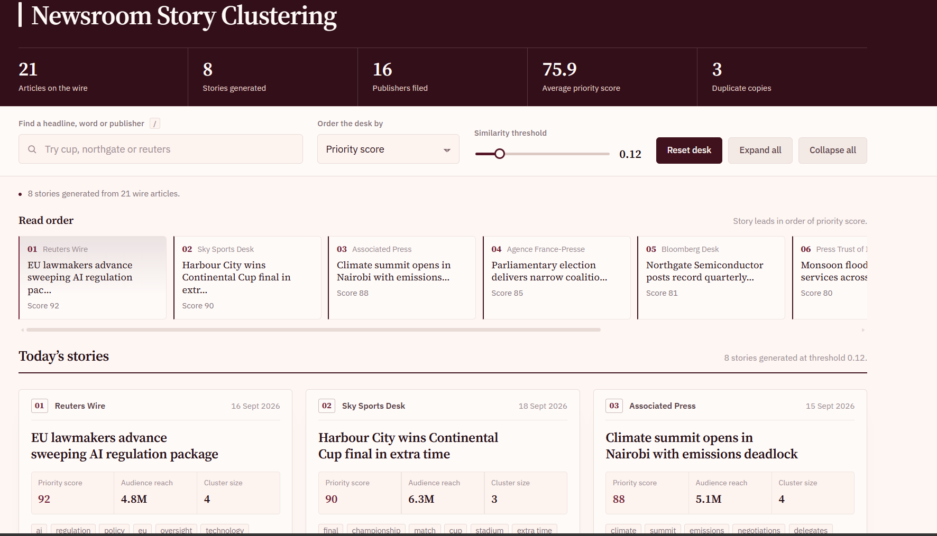
Figure 7.1: Dashboard – desk statistics, read order and story cards
The dashboard shows the desk totals (articles on the wire, stories generated, publishers, average priority score and duplicate copies) and the story leads in max-heap read order at the 0.12 similarity threshold. Each story card lists its lead headline, publisher, priority score, audience reach and cluster size.
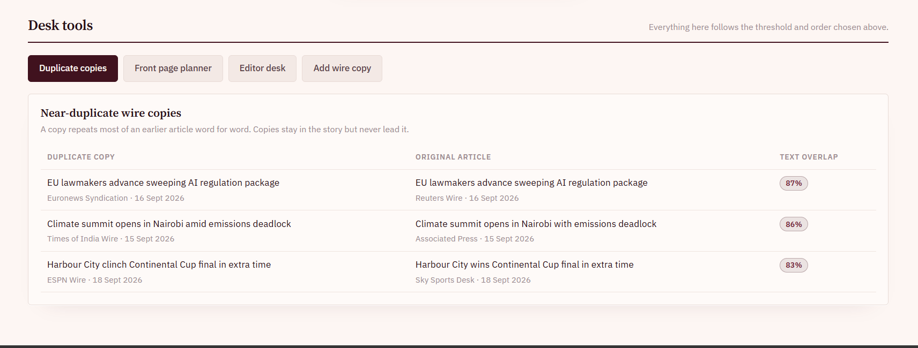
Figure 7.2: Desk tools – near-duplicate wire copies
The Duplicate copies tab lists every copy flagged by Jaccard similarity next to its original article: the Euronews, Times of India and ESPN copies overlap 87%, 86% and 83% with the originals. Copies stay in their story but never become its lead.

8. CONCLUSION & FUTURE SCOPE
Conclusion
This project shows how real newsroom problems can be solved with core DSA concepts. All six objectives were met: similar articles are grouped automatically into story clusters, near-duplicate copies are detected, each story has a lead article, stories are ranked by priority, reach or date, search and a dashboard are provided, and the front page, editor desk and publisher coverage are planned with DP, max flow and greedy set cover. By combining a frontend, a backend, a database and thirteen algorithms, the platform is:
- Faster – hashing and MinHash avoid slow full-text comparison.
- Cleaner – duplicates are removed and each story appears as one card.
- Smarter – ranking, search, front-page planning and editor tools live in one dashboard.
Future Scope
Near term
- Live news feeds: read RSS and wire APIs in real time instead of sample JSON.
- Entity tagging: detect people, places and organisations for better grouping.
Medium term
- Scale with LSH: add MinHash LSH banding so only likely pairs are compared, handling millions of articles.
- Multilingual stories: cluster Hindi, Telugu and English reports of the same event.
Long term
- Meaning-based similarity: use sentence embeddings to catch heavily reworded stories.
- Cloud deployment: host on the cloud with PostgreSQL and user logins.

9. REFERENCES
1. A. Z. Broder, “On the resemblance and containment of documents,” Proc. Compression and Complexity of SEQUENCES, 1997, pp. 21–29. https://doi.org/10.1109/SEQUEN.1997.666900
2. M. S. Charikar, “Similarity estimation techniques from rounding algorithms,” Proc. 34th ACM STOC, 2002, pp. 380–388. https://doi.org/10.1145/509907.509965
3. M. Henzinger, “Finding near-duplicate web pages: a large-scale evaluation of algorithms,” Proc. ACM SIGIR, 2006, pp. 284–291. https://doi.org/10.1145/1148170.1148222
4. G. S. Manku, A. Jain and A. Das Sarma, “Detecting near-duplicates for web crawling,” Proc. WWW, 2007, pp. 141–150. https://doi.org/10.1145/1242572.1242592
5. A. Das, M. Datar, A. Garg and S. Rajaram, “Google News personalization: scalable online collaborative filtering,” Proc. WWW, 2007, pp. 271–280. https://doi.org/10.1145/1242572.1242610
6. R. E. Tarjan, “Efficiency of a good but not linear set union algorithm,” Journal of the ACM, 22(2), 1975, pp. 215–225. https://doi.org/10.1145/321879.321884
7. J. Leskovec, A. Rajaraman and J. D. Ullman, Mining of Massive Datasets, Ch. 3 “Finding Similar Items,” Cambridge University Press. http://www.mmds.org/
8. D. E. Knuth, J. H. Morris and V. R. Pratt, “Fast pattern matching in strings,” SIAM Journal on Computing, 6(2), 1977, pp. 323–350. https://doi.org/10.1137/0206024
9. J. Edmonds and R. M. Karp, “Theoretical improvements in algorithmic efficiency for network flow problems,” Journal of the ACM, 19(2), 1972, pp. 248–264. https://doi.org/10.1145/321694.321699
10. V. Chvátal, “A greedy heuristic for the set-covering problem,” Mathematics of Operations Research, 4(3), 1979, pp. 233–235. https://doi.org/10.1287/moor.4.3.233
11. Flask Documentation, Pallets Projects. https://flask.palletsprojects.com/
12. SQLite Documentation. https://www.sqlite.org/docs.html

